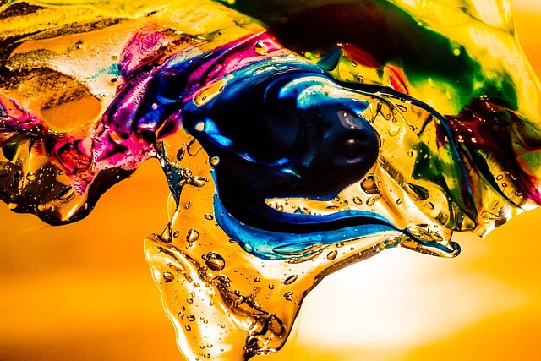

## Abstract Painting

Rs: 7,999

A beautiful piece of art that will enhance the grace of your home.

##### Key Features:

* Amazing Design
* Attractive Art
* Beautiful Color Palette
* Hand-Painted on High-Quality Canvas
* Perfect for Home and Office Decor